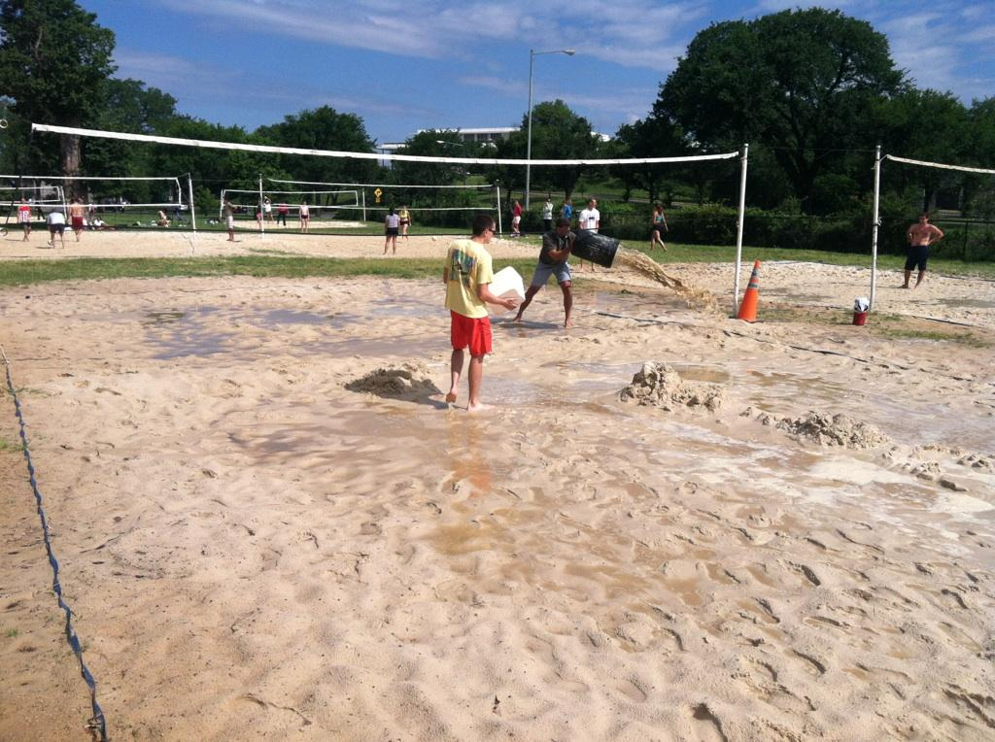
DC Sand Doubles
Volleyball
June 2nd, 3rd, 2012
For the 62nd Tournament we
overcame tornados and a
deluge Friday night.

Although delayed Saturday
morning, we accomplished
9 Divisions over this fantastic
weekend. In the future, teams
that withdraw after registration
deadline will forfeit their fee.
We did have over 230
competitors and everything
Else went well.

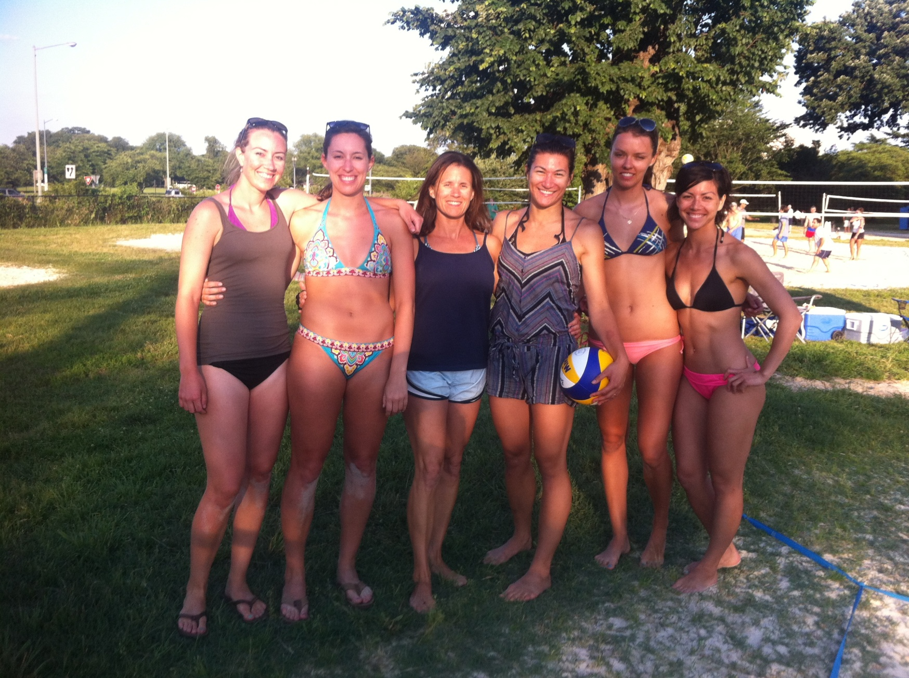

Women’s Open Winners

Winners (listed in order of finishing):

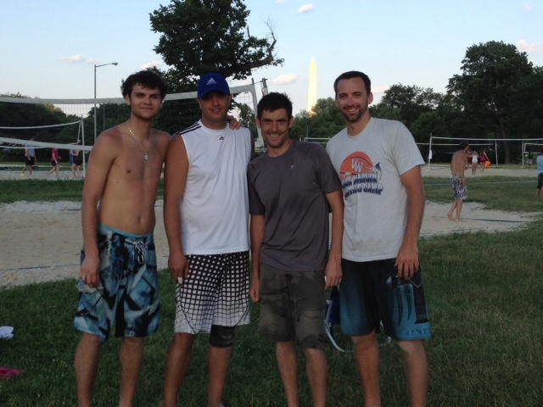

Men’s Open

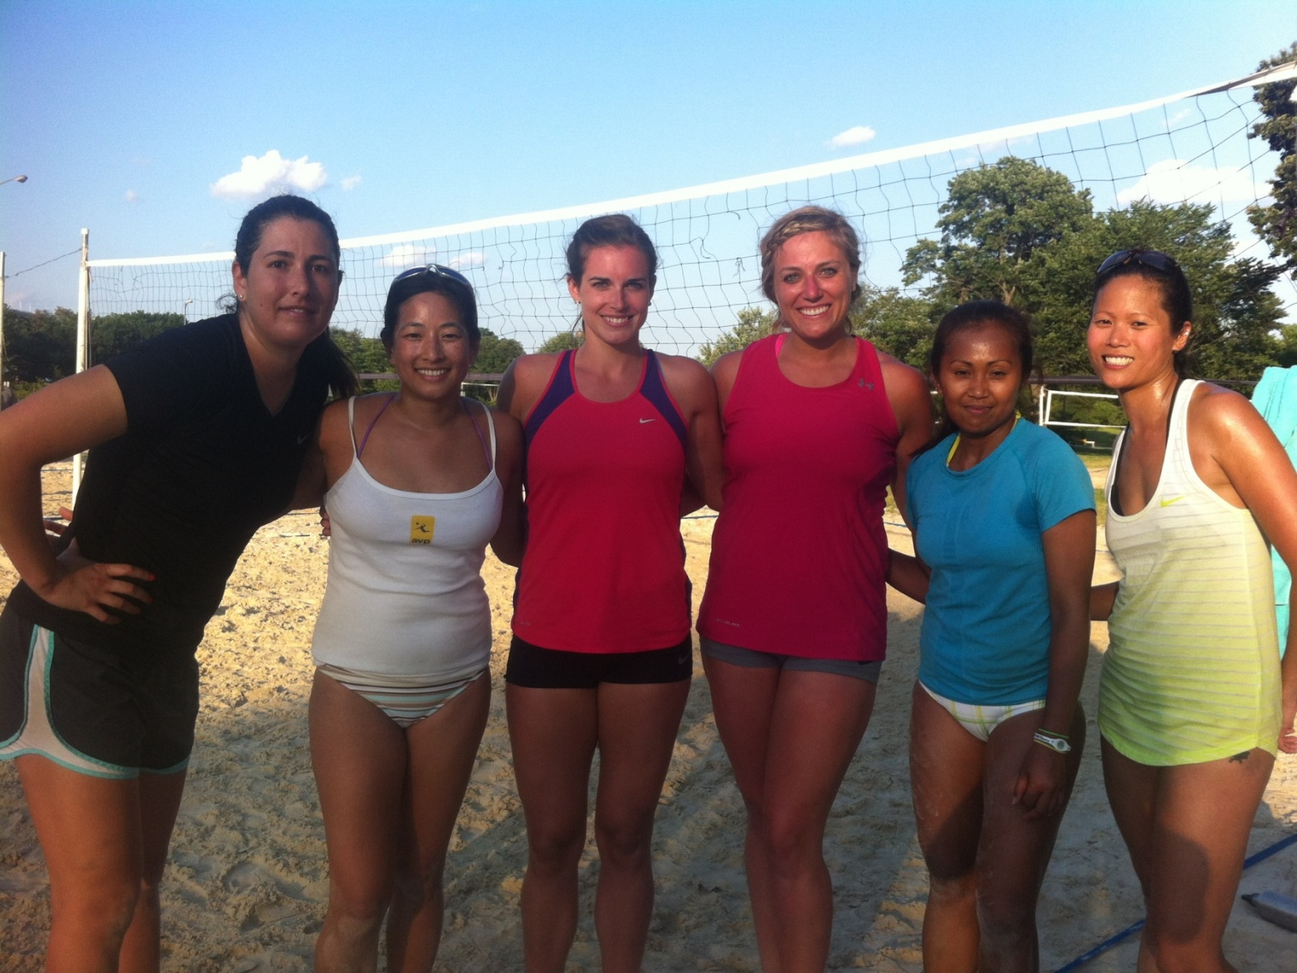
Women’s A

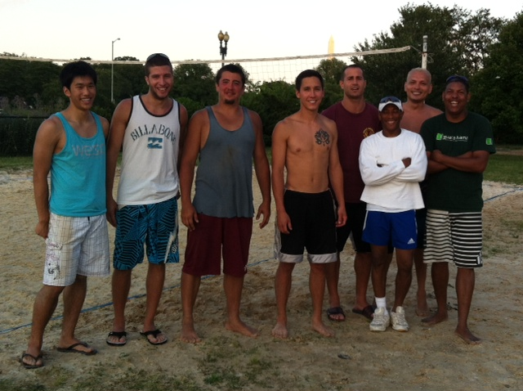
Men’s A

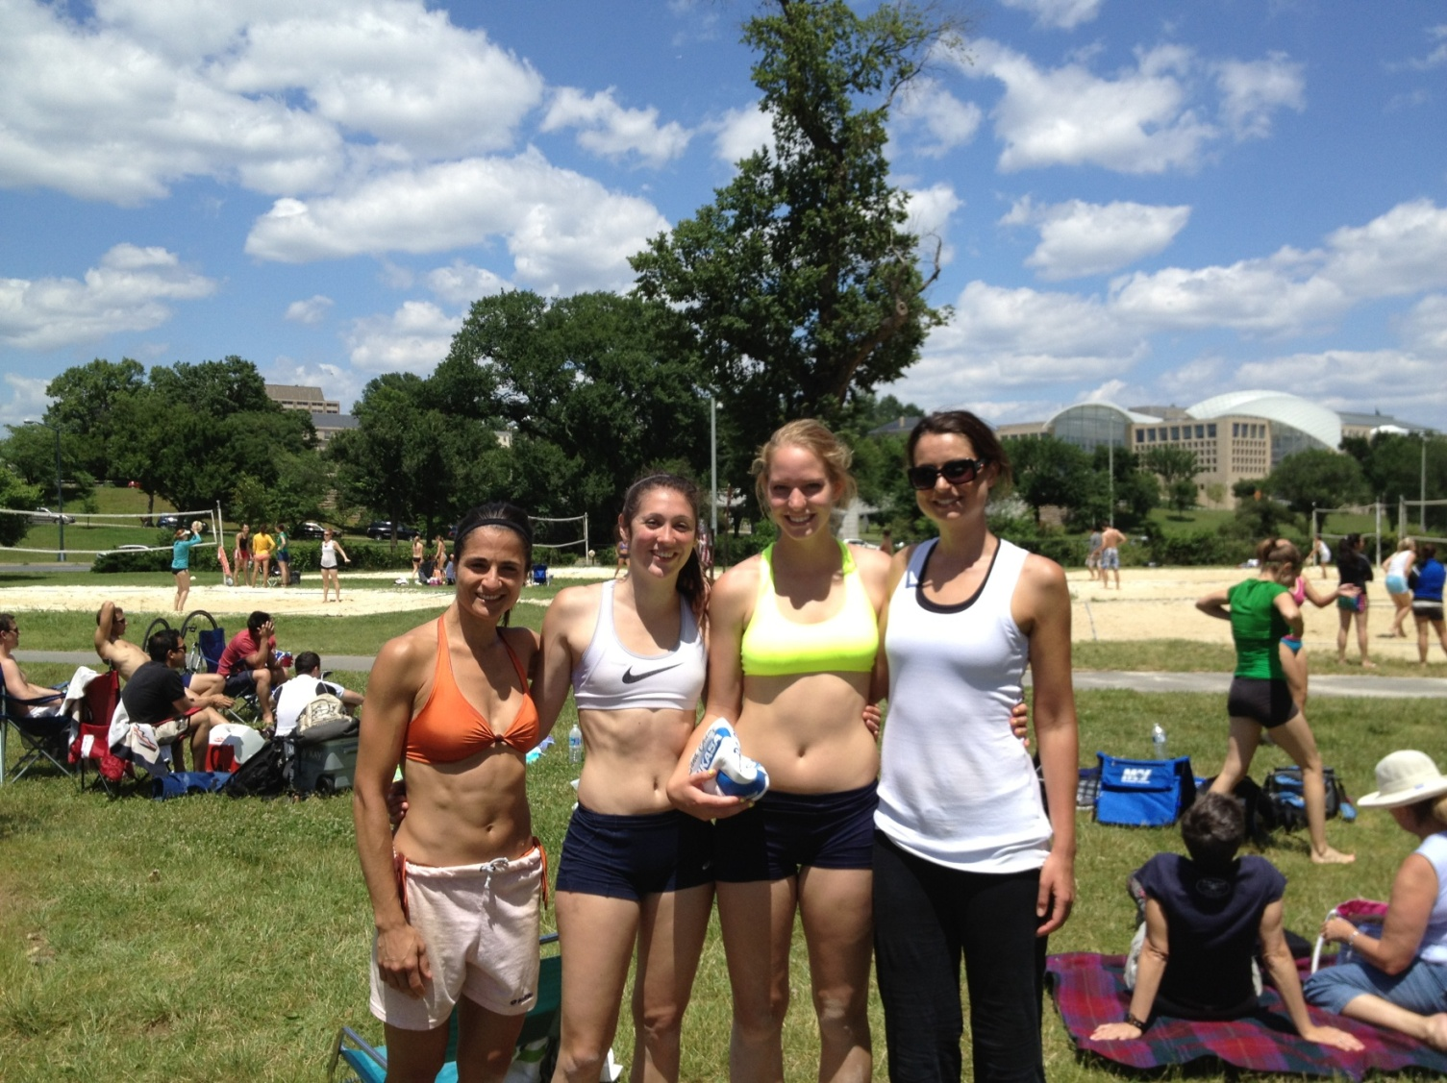
Women’s B

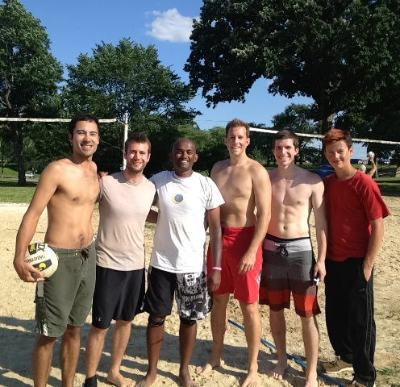
Men’s B

The next DC Sand Doubles Volleyball
September 29th (coed), 30th (m/w), 2012

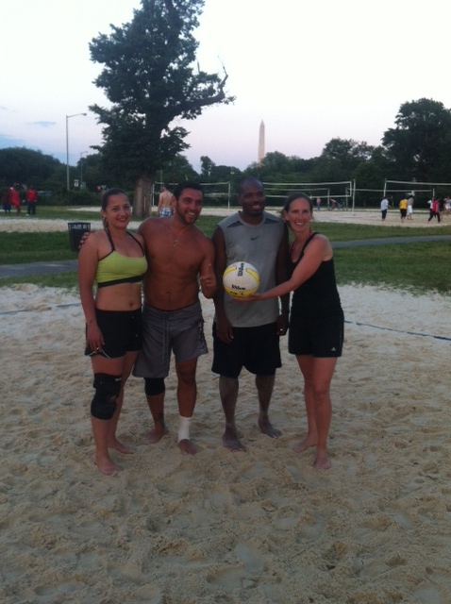

Coed A

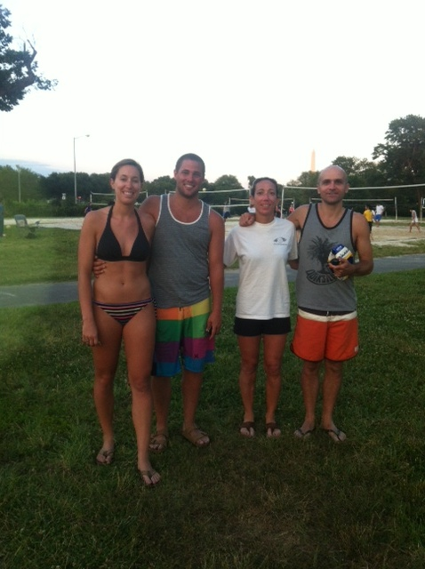
Coed Open

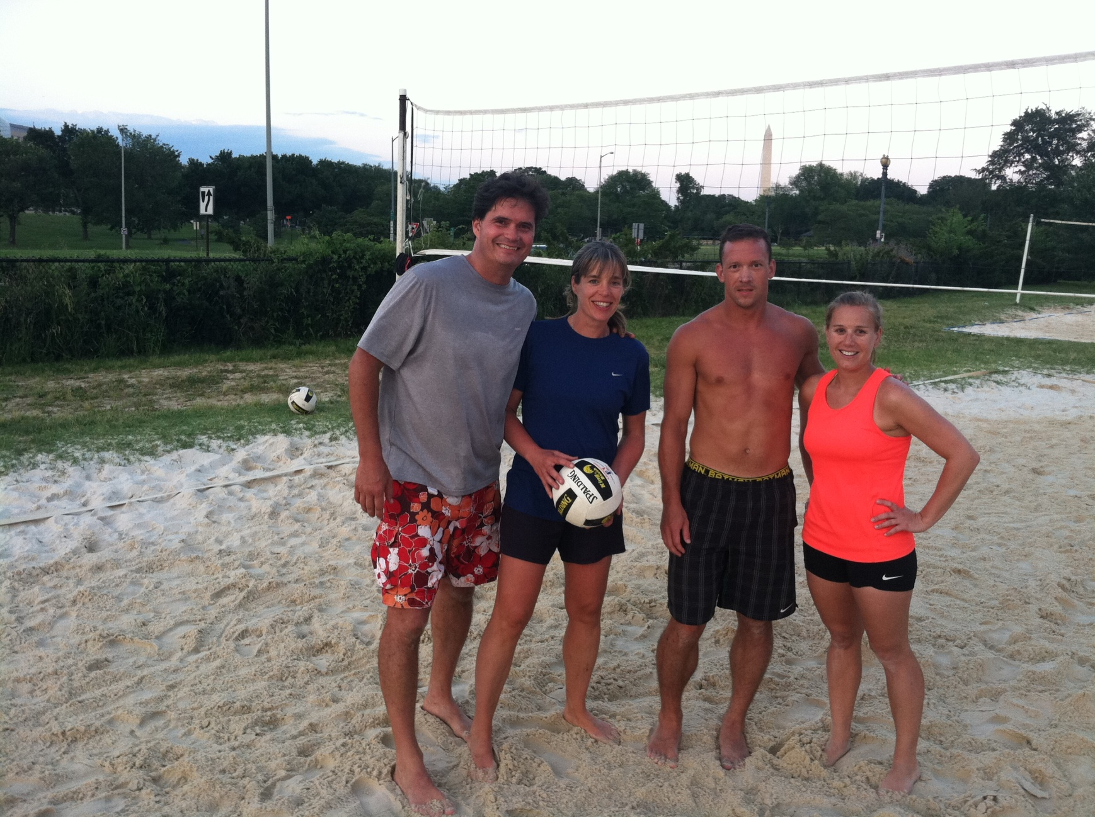
Coed B

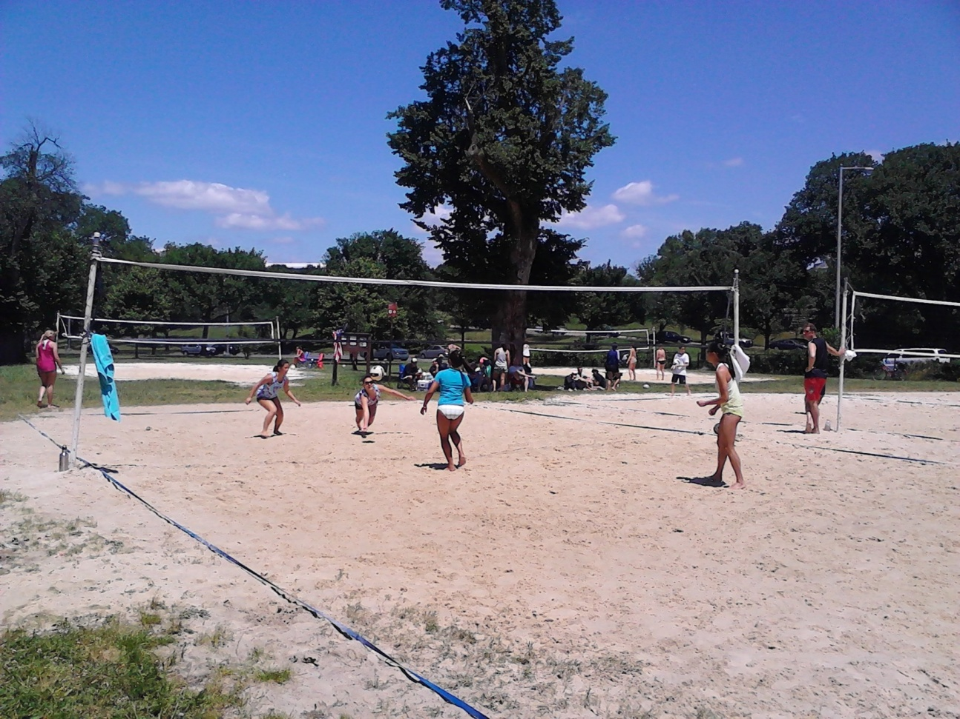
Additional Spring 2012 pictures here (www.dcdoubles.com).

